AMRITA SCHOOL OF ENGINEERING
23RAI398 MINI PROJECT

ASSIGNMENT – 2

Structured & Algorithmic Robotic Concept Development

1. Assignment Objective
The objective of this assignment is to develop and evaluate multiple robotic design concepts for the proposed duck-inspired companion robot using structured engineering methods.
This includes defining the functional architecture, algorithmic behavior, and alternative design approaches, followed by a systematic evaluation to select the most feasible concept for prototype development.

2. Project Details
Project Title :QUANC
Team Members:

3. Problem Re-Definition

3.1 Refined Problem Statement
Develop a compact indoor robotic companion (QUANC) that can detect environmental hazards and basic human presence while providing simple, friendly interaction for elderly individuals living alone, without relying on intrusive surveillance or medical monitoring systems.

3.2 Target Users / Application Environment
Target Users: Elderly individuals living independently and their caregivers.
Application Environment: Indoor home environments such as bedrooms or living rooms.
Operating Conditions: Normal household conditions with moderate lighting, typical indoor temperatures, and limited obstacles.

3.3 Constraints
Budget: Limited student prototype budget (~₹10k–₹20k).
Size: Compact indoor robot (< 40 cm height).
Power: Battery-powered system with limited runtime.
Environment: Designed only for indoor home environments.
Safety: Must operate safely around humans and furniture.

4. Functional Decomposition of Your Assigned Robot

4.1 Overall System Function
Provide friendly companionship and environmental awareness for an elderly individual living alone by sensing surroundings, detecting presence, and communicating important events.

4.2 Functional Breakdown
Main Function | Sub Functions | Expected Output
Sensing | Gas detection, temperature & humidity sensing, light sensing, human presence detection | Environmental data and presence status
Decision / Control | Process sensor data, detect abnormal conditions, decide robot behavior | Control commands and alert decisions
Actuation | Biped movement, head movement, eye expression display | Physical movement and expressive feedback
Communication | Send alerts to caregiver, provide status indication | Notifications and system feedback
Power Management | Battery supply, voltage regulation, power monitoring | Stable power distribution to subsystems

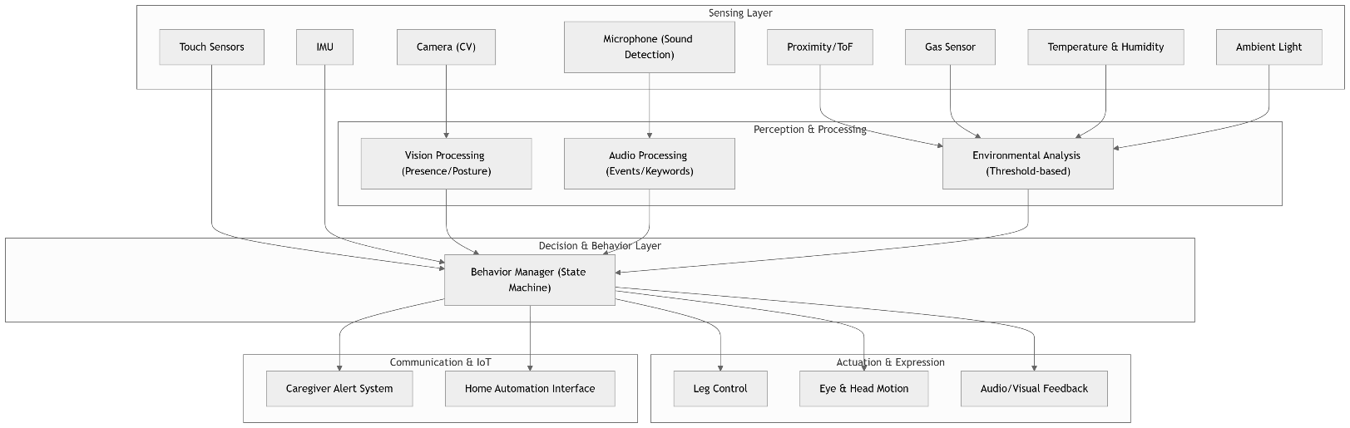
4.3 Functional Block Diagram

5. Algorithmic Design

5.1 Control Flowchart
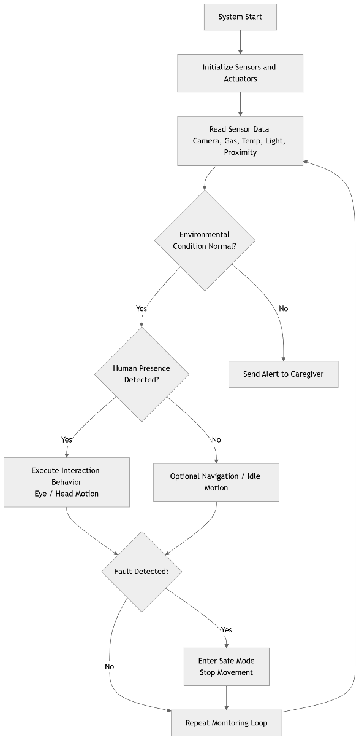

5.2 Pseudocode
Start system
Initialize sensors and actuators
While system is running:
Read environmental sensors
Read presence detection sensors

If environmental hazard detected:
Send alert to caregiver
If human presence detected:
perform interaction behavior
(eye movement / head motion)
Else:
remain idle or perform slow movement
Check system health
If fault detected:
stop movement
enter safe state
End loop

6. Concept Generation (Minimum 2–3 Concepts Required)
You must generate at least two to three different design approaches for solving the SAME assigned project problem.

Concept 1 – Mechanical-Dominant Approach
- Working Principle
- Locomotion Type
- Sensor Strategy
- Actuation Method
- Autonomy Level
- Advantages
- Limitations
- Sketch (Mandatory)

Concept 2 – Sensor/AI-Dominant Approach
- Working Principle: Explain how sensing, perception, data processing, or AI plays the primary role in system performance.
- Sensor Strategy (Advanced / Multi-sensor / Vision / ML-based):
- AI / Processing Method (Rule-based / ML / Deep Learning / Computer Vision):
- Actuation Method:
- Level of Autonomy (Manual / Semi / Fully Autonomous):
- Advantages (Higher intelligence, adaptability, data-driven decisions, etc.):
- Limitations (Cost, computational requirement, complexity, etc.):
Include a labelled sketch clearly showing sensor placement and processing unit.

Concept 3 – Hybrid / Alternative Architecture
- Working Principle: Describe how this approach combines mechanical robustness with intelligent sensing/control or proposes a completely alternative architecture.
- Sensor Strategy:
- Control Strategy (Conventional + AI / Distributed control / Edge computing etc.):
- Actuation Method:
- Level of Autonomy:
- Advantages (Balanced performance, redundancy, flexibility, etc.):
- Limitations (Integration complexity, synchronization challenges, etc.):
Include a labelled sketch clearly highlighting integration between subsystems.

7. Concept Sketches (Mandatory)
Include: - Isometric or perspective view - Labeled components - Sensor placement - Actuator locations - Control unit - Power source
Hand sketches are permitted but must be neat and properly labeled.

8. Concept Evaluation & Selection

8.1 Evaluation Criteria
Define criteria relevant to your project.
Example:
Criteria | Weight (%)
Technical Feasibility
Cost
Ease of Fabrication
Autonomy Capability
Safety
Sustainability
Scalability

8.2 Decision Matrix
Criteria | Weight | Concept 1 | Concept 2 | Concept 3
Total Score

8.3 Selected Concept
Clearly state: - Final selected design - Justification - Trade-offs considered - Reasons for rejecting other concepts

9. Proposed System Architecture (Selected Concept Only)

9.1 Hardware Architecture
List: - Microcontroller / SBC - Sensors - Actuators - Motor drivers - Communication modules - Power system

9.2 Software Architecture
Describe: - Control logic - Level of autonomy - Algorithm type (Rule-based / ML-based / Hybrid) - Data flow structure

10. Risk & Feasibility Analysis
Risk | Probability | Impact | Mitigation Strategy

11. Innovation Statement (150 Words)
Explain: - What makes your solution innovative? - How is it different from existing systems? - What engineering value does it add?

12. Sustainability & Ethical Considerations
Discuss: - Energy efficiency - Environmental impact - Safety aspects - Social implications

